|  |  |
| --- | --- |
| 2c | Batch Orchestrator: CRMGPS-4280  Advisory Technology Group |
| Prepared by: | Capgemini |
| Date: | 02/11/2014 |
| Version: | v 1.0 CONFIDENTIAL |

*Morgan Stanley Research Runbook*Morgan Stanley  
©2008 Morgan Stanley

All rights reserved. This document is intended for use by Morgan Stanley employees only. Any distribution or reproduction of this document without the written permission of Morgan Stanley is strictly prohibited.

# Contents

Version History 4

Overview: 5

Configuration: 6

Steps to use Batch Orchestrator: 6

Technical Description 6

Error Handling: 6

Job Detail Object 7

Batch Manager Log: 9

Scheduler Log Object: 10

# Version History

|  |  |  |  |  |  |
| --- | --- | --- | --- | --- | --- |
| Version | Date | Created by | Reviewed By | Distribution | Modifications |
| 1.0 | 11/02/2014 | Amit Tripathi |  |  | Initial Draft |
|  |  |  |  |  |  |
|  |  |  |  |  |  |

# Overview:

This document illustrates the purpose and design aspects of Orchestrator for Batches in GPS application.

Currently we have limitation where in more than 5 batches are not allowed to run in parallel which leads to failing of Jobs. This document aims to address the issue and proposes solution to manage all the batches centrally allowing us to have better control by enabling queuing mechanism.

Currently the solution does not addresses linking (one batch calls other batch) and dependent (execution of one job is dependent whether other job has run or not) Batch Jobs but can be extended to include this as well.

## Configuration

1. The configuration details are stored in Custom Setting Job Scheduler Setting.
2. We need to set admin email, scheduler frequency and days to purge old log in this custom setting.

|  |  |
| --- | --- |
| Field Label | Description |
| [Admin Email](https://morganstanley--devt1.cs3.my.salesforce.com/00NQ0000001IyhE) | Error email will be sent to this email address |
| [Frequency](https://morganstanley--devt1.cs3.my.salesforce.com/00NQ0000001Ixg5) | This is the frequency of scheduler job |
| [Purge Logs Earlier Than](https://morganstanley--devt1.cs3.my.salesforce.com/00NQ0000001Iy0t) | This will keep log records for mentioned days only |

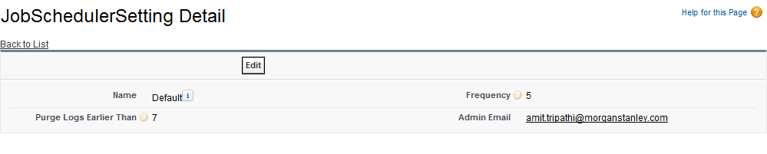

## Steps to use Batch Orchestrator:

1. Enter job details in Job Detail object.
2. Check the Job log and Scheduler Log to get the job status.

## Technical Description

1. A schedulable class JobScheduler, will run at specified intervals as low as 5 min and will query the AsyncApexJob object /Job Details object to determine the course of action.
2. It will pass the actual execution to Class JobSchedulerManager where actual execution (Evaluating Jobs, Running Jobs, Updating Logs) will take place.

## Error Handling

1. If any job failed consecutively then the email will be sent to administrator containing detail error log.
2. Consecutive failed status can be check in Job log or Scheduler Log.

## Job Detail Object:

(Top)

A custom Object “Job Detail” to hold the individual Job information, a central repository to read/locate batch and various aspects of it like Class, frequency to run at and of course related logs.

|  |  |
| --- | --- |
| Fields | Description |
| Batch Job Name | Utilizes standard Name field. To hold the Batch Name. ex. RefreshRDMs Weekly. |
| Active | Checkbox field to indicate that the batch is active and should be evaluated. |
| Apex Class | Exact name of Batchable class. Instance of this class will be created and Used in Database.Executebatch statement. |
| Last Run | DateTime field to indicate the instance of last run for this batch. |
| Next Run | DateTIme fields to indicate the Next Run time for the batch. Based on this field batches will run. |
| Recurrence Unit | Picklist field holding Unit of frequency of Batch Job e.g. If the batch needs to run daily then frequency will be Days.   |  |  | | --- | --- | | |  | | --- | | Values are:  Min  Hrs  Days  Weeks  Months | | |
| Recurrence Number | Number field to hold the integr part of frequency. E.g. For daily occurrence of job this will be 1. |
| Scope Size | Number field to hold the scope size of the batch if any, default value is 200 but for some batches it cannot be more than 3 . |
| Priority | This field is use to set priority of batch job |

E.g. Job to run every 2 Hour.

Recurrence Unit-“Hours” & Recurrence Number -2.

For Job to run only at weekend.

Next Run will be current Weekend and ,Recurrence Unit will be Week and Recurrence Number will be 1.

So combining with Next Run/Last Run field and doing calculations we can determine the Next Run of the batch.

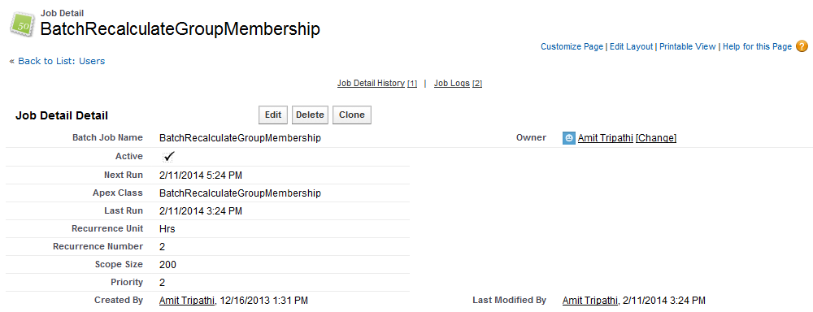

## Batch Manager Logs

(Top)

A custom Object “Batch Manager Logs”, a child to Job Detail object will hold the latest batch logs.

|  |  |
| --- | --- |
| Field | Description |
| Completion Date | Job Complete Date for this instance of Job. |
| Trigger/JobId | Job Id for this instance of job. |
| JobDetail | Lookup to Job Details Record. |
| Error | Text Area field to hold the errors reported for this instance of Job. |
| Status | A Text Field to denote the status of this job instance.  Current values include: Running, Completed, Queued |

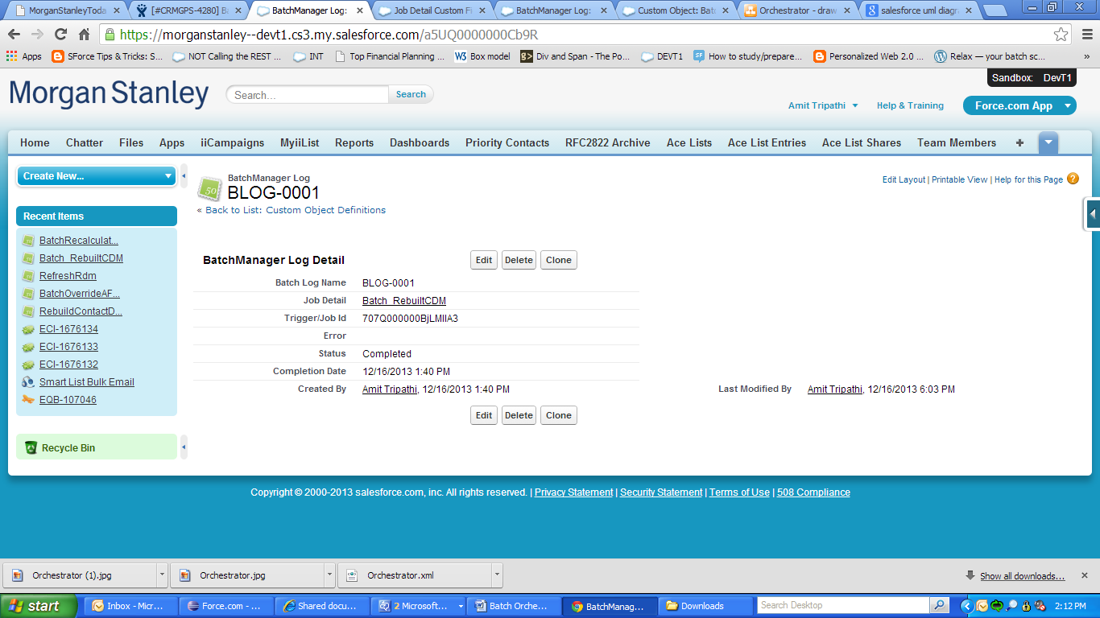

## Scheduler Log Object

(Top)

|  |  |
| --- | --- |
| Field Label | Description |
| [Description of Error](https://morganstanley--devt1.cs3.my.salesforce.com/00NQ0000001IxgU?setupid=CustomObjects) | Text Area field to hold the errors reported for this instance of Job |
| [Next Job Id](https://morganstanley--devt1.cs3.my.salesforce.com/00NQ0000001IxgZ?setupid=CustomObjects) | Id of next job to be schedule |
| [Run Time](https://morganstanley--devt1.cs3.my.salesforce.com/00NQ0000001IxgK?setupid=CustomObjects) | Next run time of the next job |
| [Status](https://morganstanley--devt1.cs3.my.salesforce.com/00NQ0000001IxgP?setupid=CustomObjects) | A Text Field to denote the status of this job instance. |

